Testing ALT text fields

Figure 1
- Title: Title for penguins
- Description: Three penguins dancing
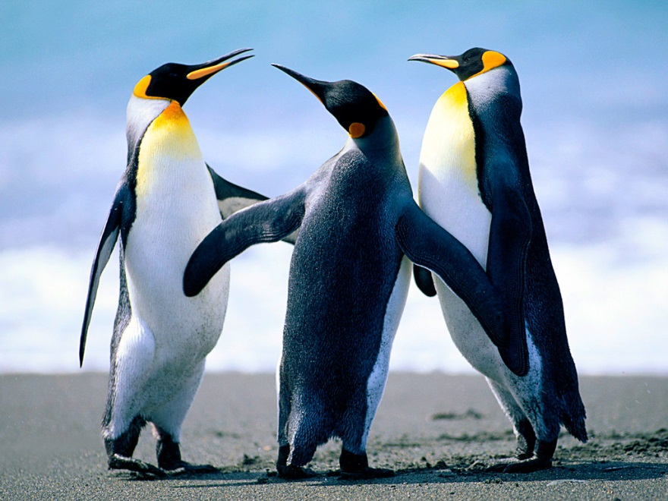

Figure 2
- Title: Title for koala
- Description: Koala, our fearless leader
